Why Zenoss & ServiceNow?
- Compress the time to identify and resolve incidents.
- Reduce manual entry by automatically synchronizing monitored devices with CMDB
- Reduce risk by ensuring event, incident and CMDB information is current, correct and complete.
High level architecture: ServiceNow Integration
ServiceNow
CIs

Incidents
ServiceNow
Devices
Events
Zenoss

Incident Management Integration – What you get
- Create incidents automatically via Zenoss triggers/notifications.
- Create incidents manually via event console
- Resolve incident when corresponding event is closed
- Resolve incident when corresponding event clears automatically
- Assign the incident to the user acknowledging the event
- Acknowledge event when corresponding incident is assigned
- Close event when corresponding incident is resolved
- Associate existing events with existing incident
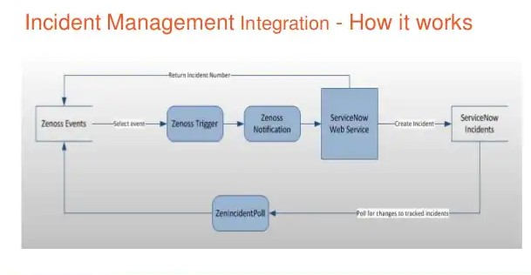
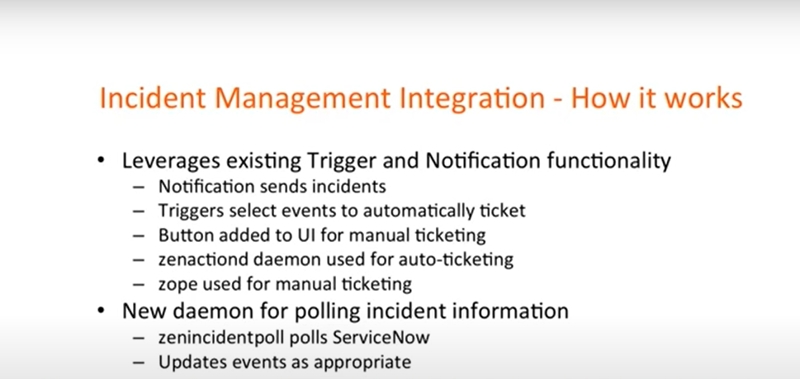
CMDB:
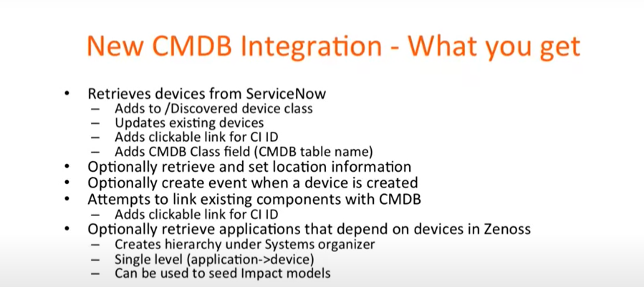
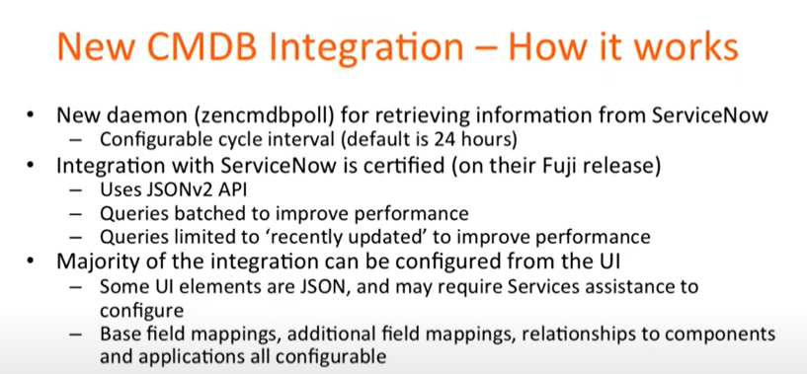
Reference: https://www.youtube.com/watch?v=Y7nR-FkdEwI

